**Tweeting about Women’s Rights and the 2016 Election**

Ling Bai (lb2921), Amanda Gates (arg2211)

Final Project

G4063 Data Processing and Visualization

**ABSTRACT** (shiny app “About” tab)

**General Terms** (need more)

Visualization

**Keywords** (need more)

Twitter, sentiment analysis, 2D visualization

**1. INTRODUCTION** (expand a bit from shiny app “About” tab?)

**2. LITERATURE REVIEW** (put some descriptions about d3 and shinny app?)

**3. THOERY AND HYPOTHESIS**

**4. DATA SOURCES AND METHODOLOGY** (here is mainly talking about the coding process)

1) About the Data

The data used in all the charts and plots are daily tweets collected from Twitter API, which are provided by Professor as csv. files. All of the following visualizations are using the exact same data source – here we’re using summary csv. files to ensure our data visualization process be more efficient and effective.

2) D3 time-series visualizations

2-1) Multi-Series Line Chart

We'll start with the multi-series line chart and look at how it gets generated first. Then, with that as a baseline, we can compare that process with that used for the other three chart types.

A multi-series line chart is a set of path elements representing the lines. In this case we want to make a line for each of the data columns representing the six different topics (feminism, men, reproductive rights, etc), so we will have a total of six path elements.

To start, the data gets loaded from the CSV file and then we need to do a little bit of data manipulation to get the data set-up to be passed to D3 to render the SVG paths. We are appending a "g" element (the "g" element allows us to group other items like a text label if we want later) for each series and then passing its "values" array to "line". After declaring the variables at the top of the script, the first key block of code looks like this:

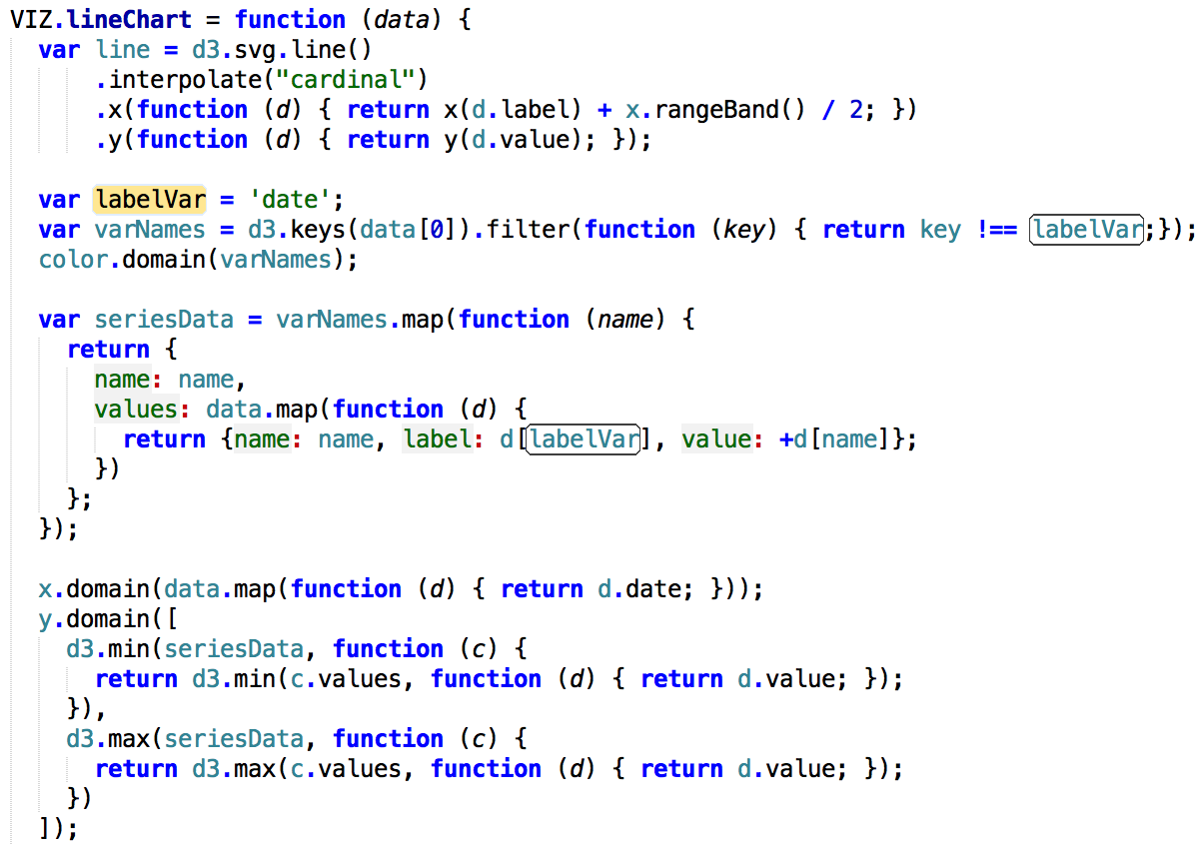

Render the Lines in D3

The last bit of code generates the paths in D3. It looks like this:

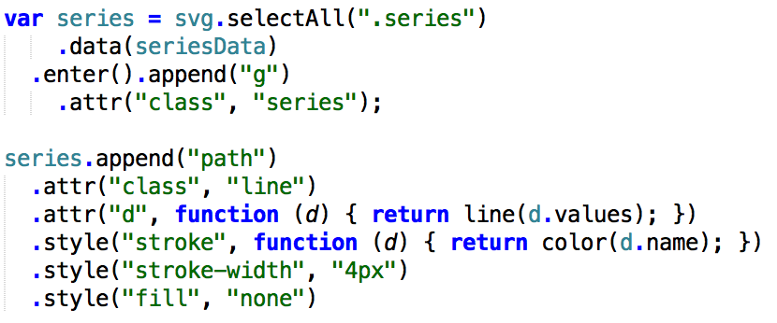

2-2) streamgraph

Now let’s take a look at bare bones example of a streamgraph. It has just the code needed to create the basic visualization, without any distracting code for things like axes and legends. After working through this section you can look at the full version with the other elements added in.

Like the multi-series line chart, the streamgraph is made up of paths for each of the series in the data. Instead of drawing lines, the paths create an irregular shape that fills the area taken up by the series. To draw the path we'll make use of the d3.layout.stack() and d3.svg.area() tools.

After the variables are declared, the first key section of the code is here:

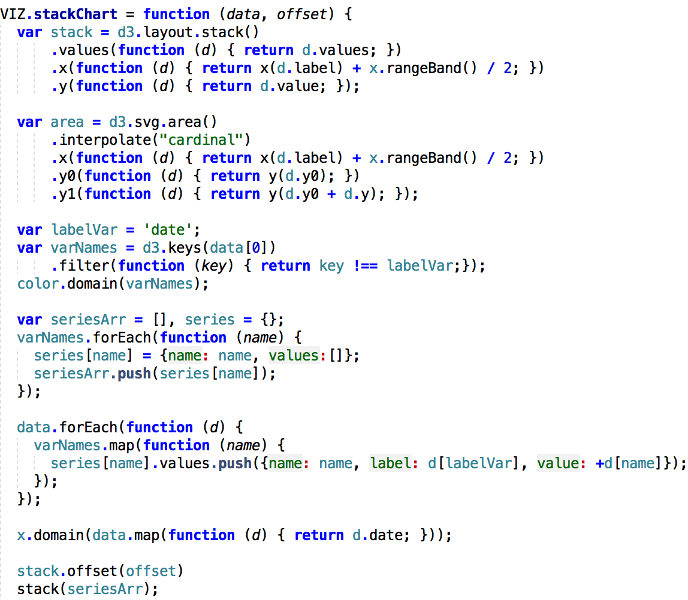

The first part of the code is exactly the same as that for the multi-series line chart. At point A we identify the categorical variable that has the labels for the chart and then, at point B, we derive an array of the variable names for each of the series. That array is then set as the domain for the color scale and will be used in several other occasions in the code.

Rendering the Streamgraph in D3

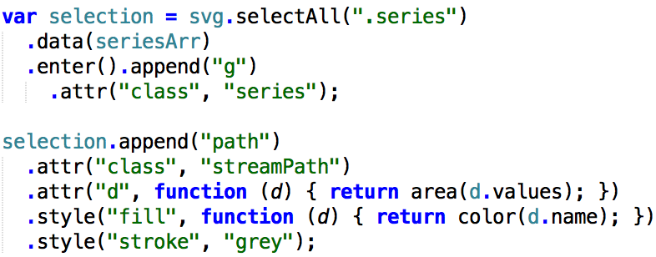

This is almost identical to the code seen above for the multi-series line chart. Each series gets a "g" element and a path is appended that represents the data series. D3 is again doing all the hard work generating the path information. We just need to send the "values" array to "area" in the code:

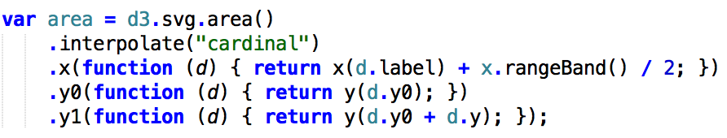

Area is one of D3's many SVG shape generators. Here, we set up d3.svg.area() with a few lines of code. In the first line, the interpolation will define the way the SVG path looks, so you can play with that to get other effects. In this case, we want to use "cardinal" to give the streamgraph the nice rounded look like we typically see on these kinds of charts. The other lines added to the d3.svg.area() code above are the accessors. We have to tell d3.svg.area() how to find the x, y0(bottom) and y1 (top) of each element in the array. We can now see how the values inserted by "stack" above are used to layout the SVG path.

2-3) Creating the Stacked Area Chart

For stacked area chart, all the codes are same as streamgraph, the only difference is to change “.interpolate("cardinal")” to “.offset(“zero”)”.

2-4) Creating the Stacked Bar Chart

For stacked bar chart, each column is a group of SVG rectangle elements. The processing of the data for this is quite a bit different than the previous ones, but the same basic steps for building the chart are unchanged: (1) derive an array of the the variable names that represent the series in the data file (2) transform the data (using the varNames array) into the the input D3 needs to layout the chart and (3) use D3 to create the SVG elements. Like we did for each of the other charts, let's look at the key part of the code:

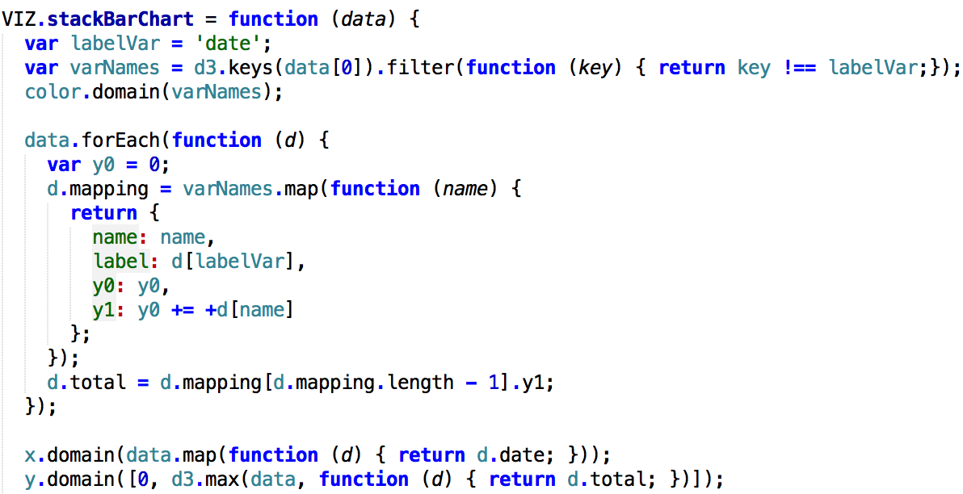

Just like the examples we've already seen, the first step is to make the varNames array with each of our variables names that will be made into series. The code is exactly the same as before. Identify the categorical variable that contains our label information at point A, create the the array by filtering out that name from the keys of data[0] at point B and then create our color domain using the array at point C. We now have a list of variable names we can iterate over when processing the data.

Rendering the Stacked Bar in D3

The code for rendering the stacked bar chart looks like this:

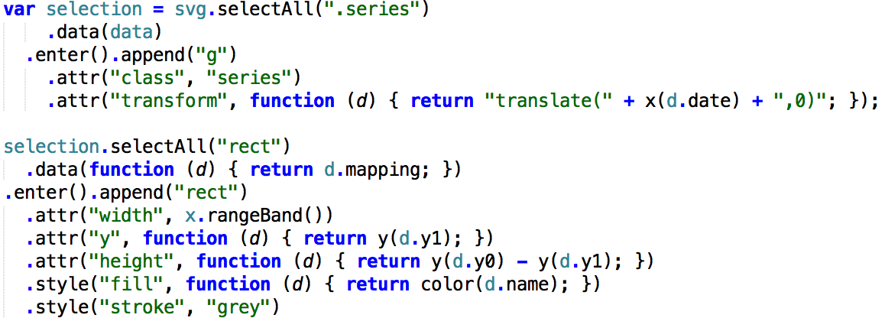

There is one important point to make about what's happening here. In the other charts we added a "g" element for each of the series. Here we are making a "g" element for each row in the data and then iterating over the "mapping" to create the column of rectangles at point A. This is a bit tricky, but a really powerful way to use D3 to iterate over a nested structure. At point A we call data again and create a new mini dataset to iterate over. This is pretty cool. In this context, we are already cycling over the records so you call data with "function (d) { return d.mapping; }" and it well return the mapping array for the record you are currently working on. Tough to get used to, but powerful.

2-5) Adding Legends, Axes and Tool-Tips

Adding Legends

The code for adding the legends is exactly the same for all four charts. We make use of the varNames array and we just need to add these lines to each chart:

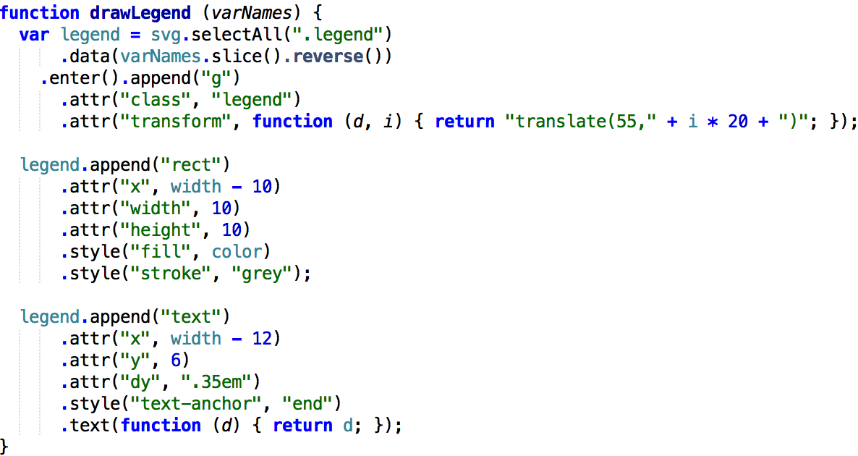

Adding Axes

Again, on the axes everything is exactly the same across all four chart types. The following lines are added and then there is also a little bit of CSS added at the top of the file, so don't miss that.

First, adding the axes requires a couple of new variables at the top of each file:

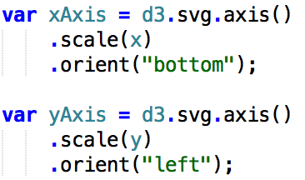

Then we draw the axes adding these lines:

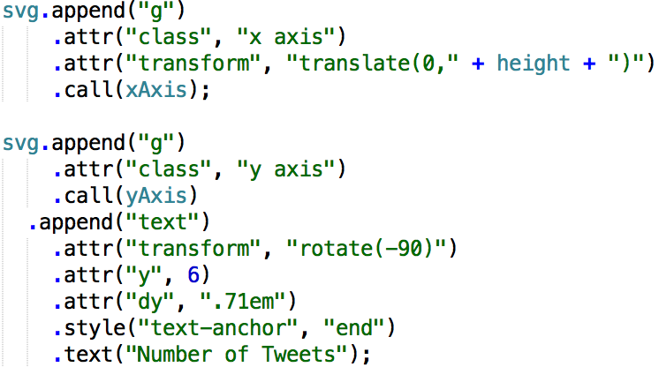

Adding Tool-Tips

For the tool-tips you see when rolling over the data points, we add in both Bootstrap and JQuery to the files. You'll see a bootstrap.css file added at the top and bootstrap.js and jquery.js added in script tags in each file. This could be done using a number of different JavaScript libraries (or none at all, really), but I like Bootstrap because it has the nice looking popovers to use for tool-tips and it's easy to use.

With the CSS file and JavaScript files in place, we just need to add two functions to each file:

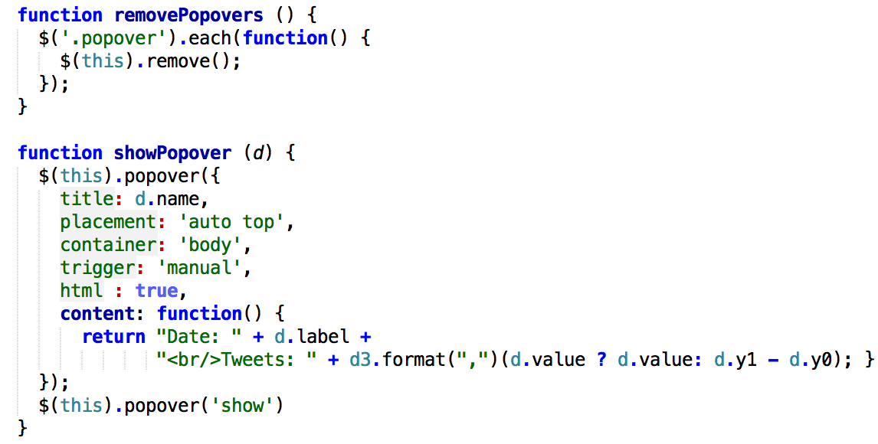

Then we can reference these function in the appropriate place in the code. For example, in the multi-series line chart, a set of circles is added to the full version for the user to mouse over. We set up the event handlers on those circle elements like this (look at the last two lines):

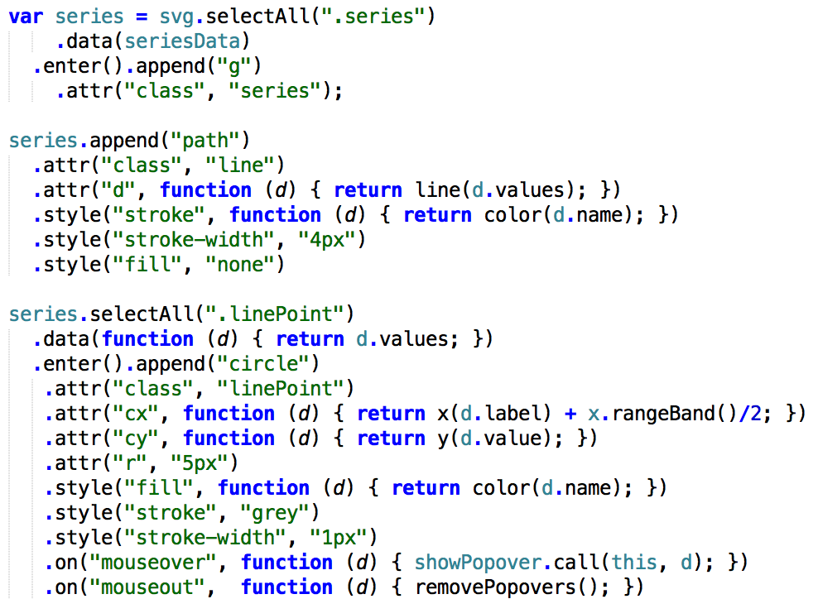

2-6) Putting All Together

Combining all the codes together, we get a chart.js file loading along with the d3.js, jquery.js, and bootstrap.js files. The chart.js essentially takes the code from each of the four chart types and makes them into functions that can be called. It also adds a new function "onResize" that keeps the chart sized correctly in the browser. There's a VIZ object that gets returned from chart.js that has all the main functions (methods) that we need to make the interactive chart.

With the new chart.js file in place, the HTML file for the example just has a few lines in it:

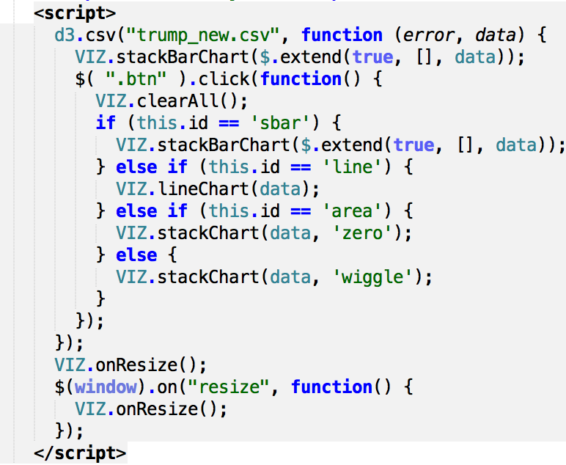

3) Sentiment analysis

Sentiment analysis is often used to quantify users or consumer sentiment about online products or services. The input could be user reviews on Amazon or Google, or tweets about particular products or companies. Sentiment analysis can also be used to measure and even predict public opinion about political candidates, markets, or brands. The input to these analyses could be tweets or web search terms, for example. The output of sentiment analysis ranges from a simple binary measure (positive vs. negative sentiment), to more complex multidimensional measures of affect and attitude. Here I'll solely focus on a continuous measure of valence, or how words make people feel, which is available from a large database of human ratings. In this project we use R to perform sentiment analysis of Twitter data. Sentiment analysis is part of a broader set of tools available in the realm of NLP (natural language processing). Here we used csv files of filtered tweets by topics.

Since we don't have get Twitter API to get tweets, we started our sentiment analysis from text processing. The tweets in the 'text' column need to be tokenized. One way to go uses the “tm” package, a comprehensive text mining framework for R. First we'll create a corpus from the tweets. Here is how we did for Hillary Clinton’s csv:

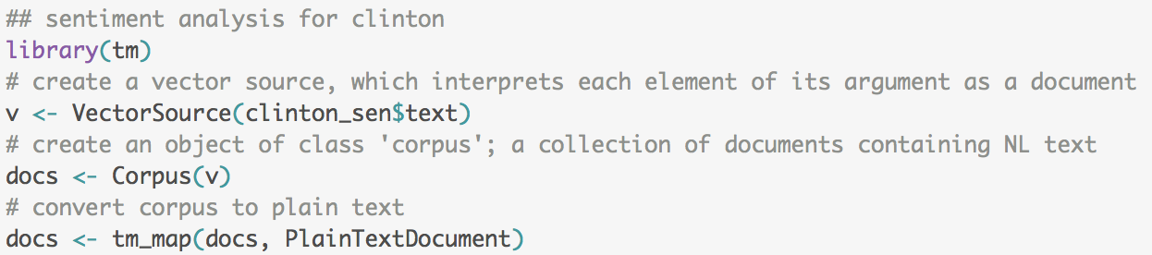

The goal now is to tokenize the raw text into units of some kind. Although there are ways to assess the sentiment of phrases and sentences, here the tokens will be individual words. Using R base functions, first convert text into the ASCII scheme and then change all text to lower case.



Then remove some of the most common words in English (e.g. you, me, my, the), that won't add anything to a sentiment analysis. These are called stop words in the NLP literature.



Next, let's remove strings that start with URL indicators.

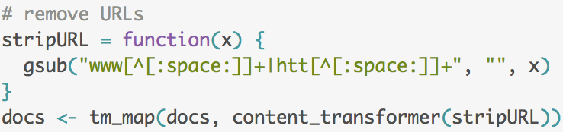

We also don't need any numbers or punctuation marks, and extra whitespace can go. I won't deal with Emoticons in this post, but one generally should. I could continue to use base R functions to clean up the text (like above), but the “tm” package has ready made functions for the common tasks.

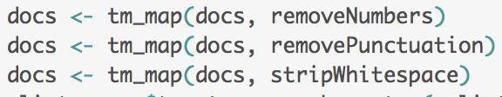

Then the last step is to convert the cleaned up text back to a character vector and attach to original data frame, then remove the original 'text' column.



After all the preparations, we first made some word clouds for each candidate by topic, which is a good way to see the most frequent words in a corpus. Since the size of the words will reflect their frequency, I'll remove the topic (twitter search term) from each tweet first; otherwise these would dominate the word clouds.

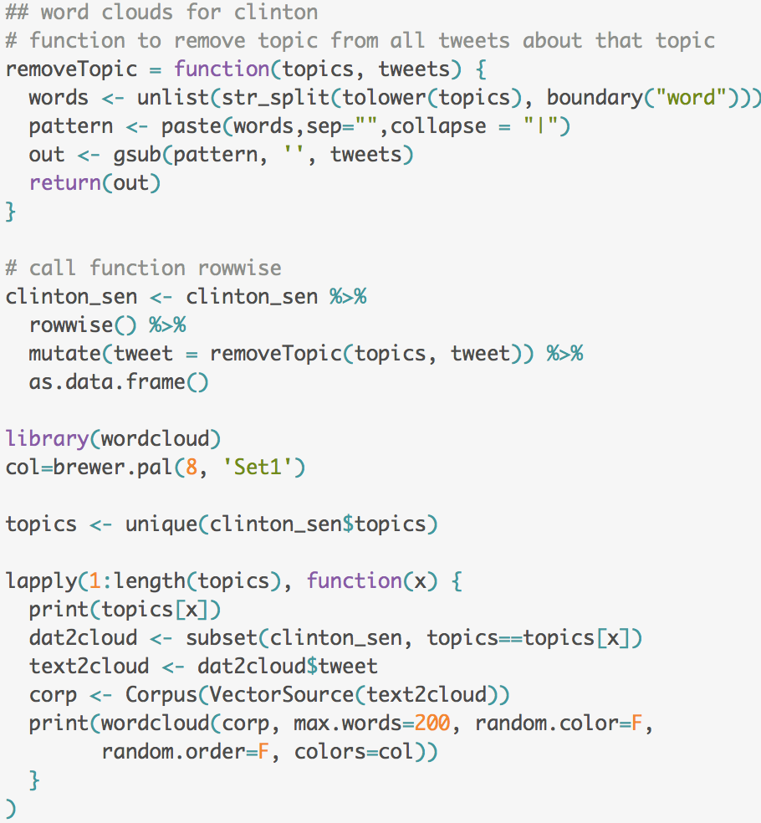

Here is the real sentiment analysis part. There are several large lexicons containing valenced (good/bad) word measures. I downloaded the affective ratings for english from Marc Brysbaert's research group at Ghent University, which contains about 14,000 English words.

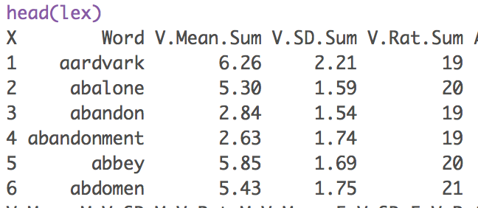

First I'll retain valenced words with ratings towards either pole of the 9-point valence rating scale. That is, words that people rated as making them feel at least somewhat happy/unhappy.



I define a function that computes the mean and standard deviation of valence for all tweets about a given topic, on a given day.

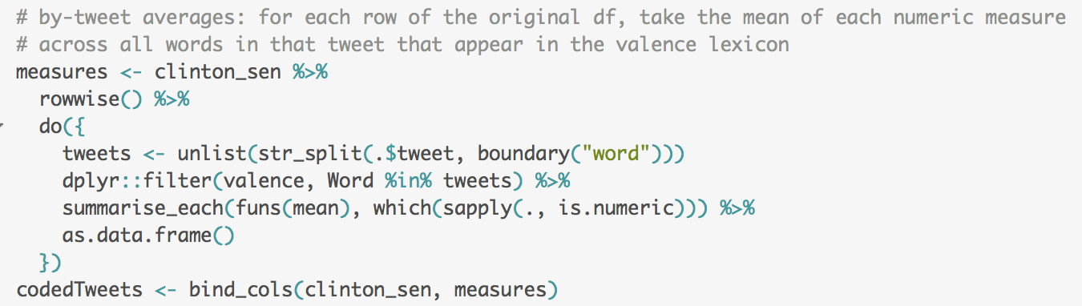

Let's look at the distribution of sentiment for each topic.

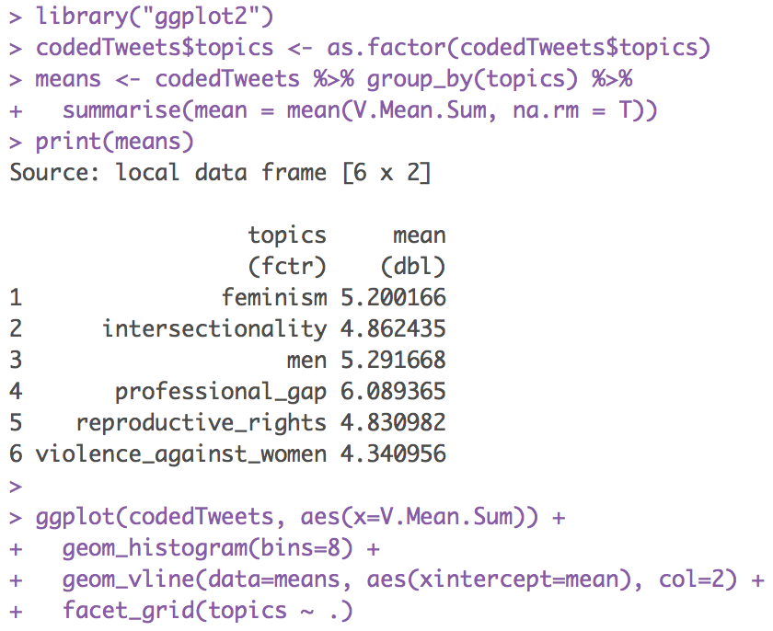

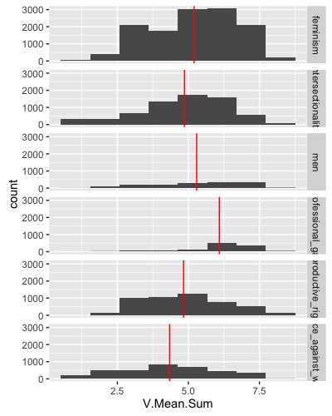

In order to answer the question whether these sentiments changing day by day, we made line-plot to visualize it.

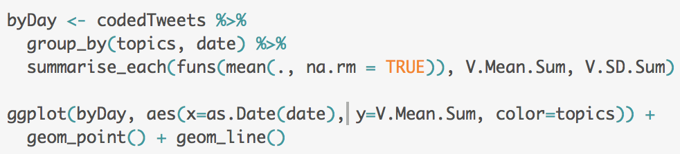

Next we want to explore how sentiment varies geographically. We'll need to bin the continuous sentiment variable first.

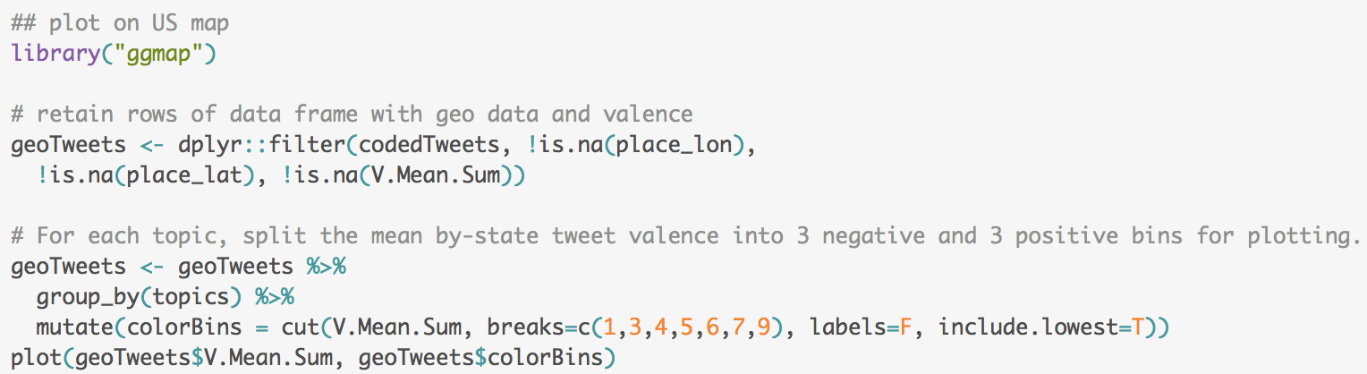

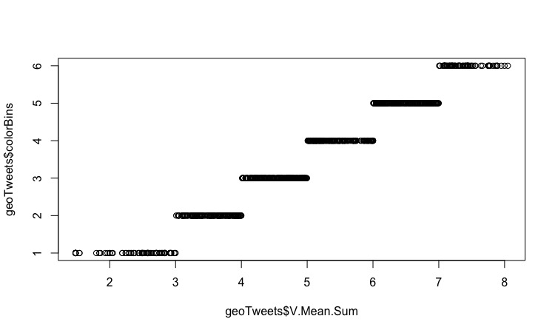

These maps via “ggmap” package show the location of every tweet about each topic. As Hillary Clinton as an example, the color of the point varies from more negative sentiment (black) to more positive sentiment (red).

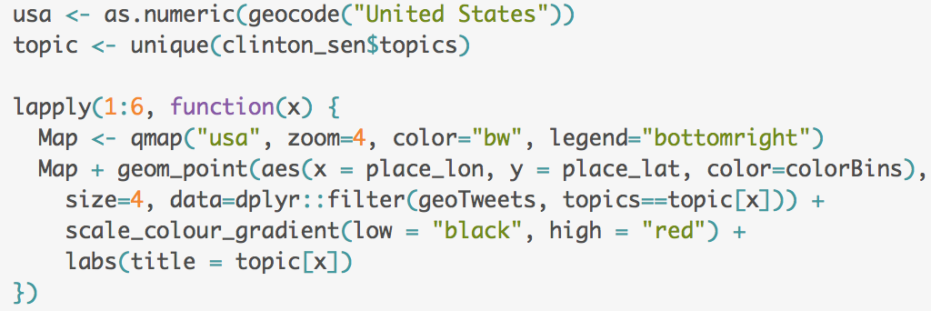

**5. PLOTS AND INTERPRETATIONS** (here is mainly talking about plots and Real-life Parallels)

From the d3 plot of Trump, we could see that there is huge increase there is huge increase on the topic of reproductive right from March 30th to April 5th. The peak appears at March 3.31st, the total number of tweets is as high as 6,609.

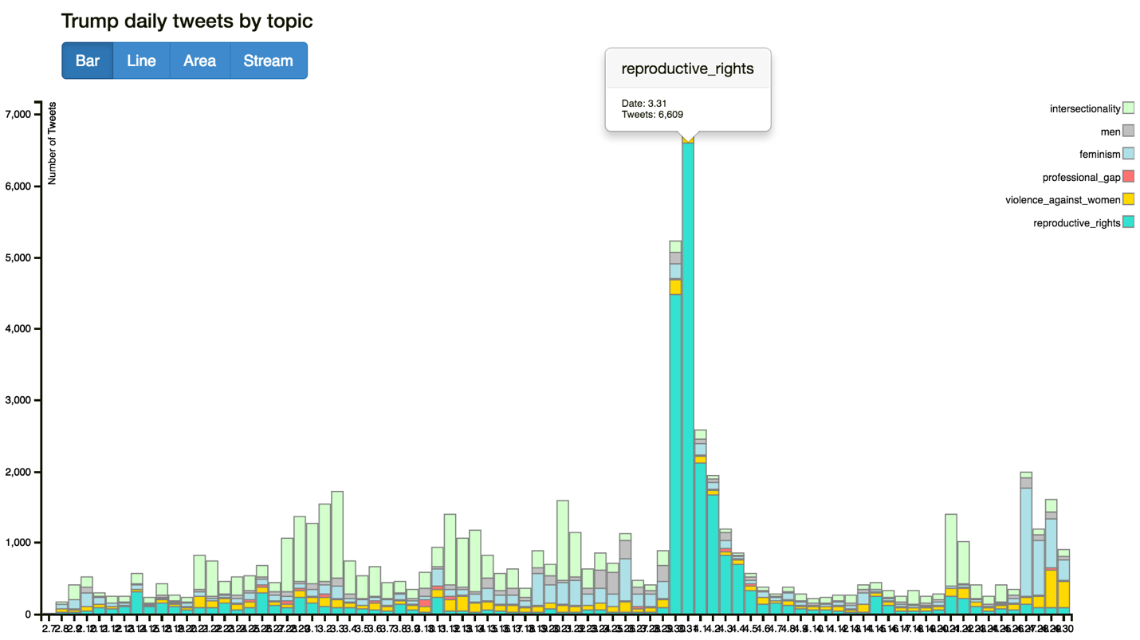

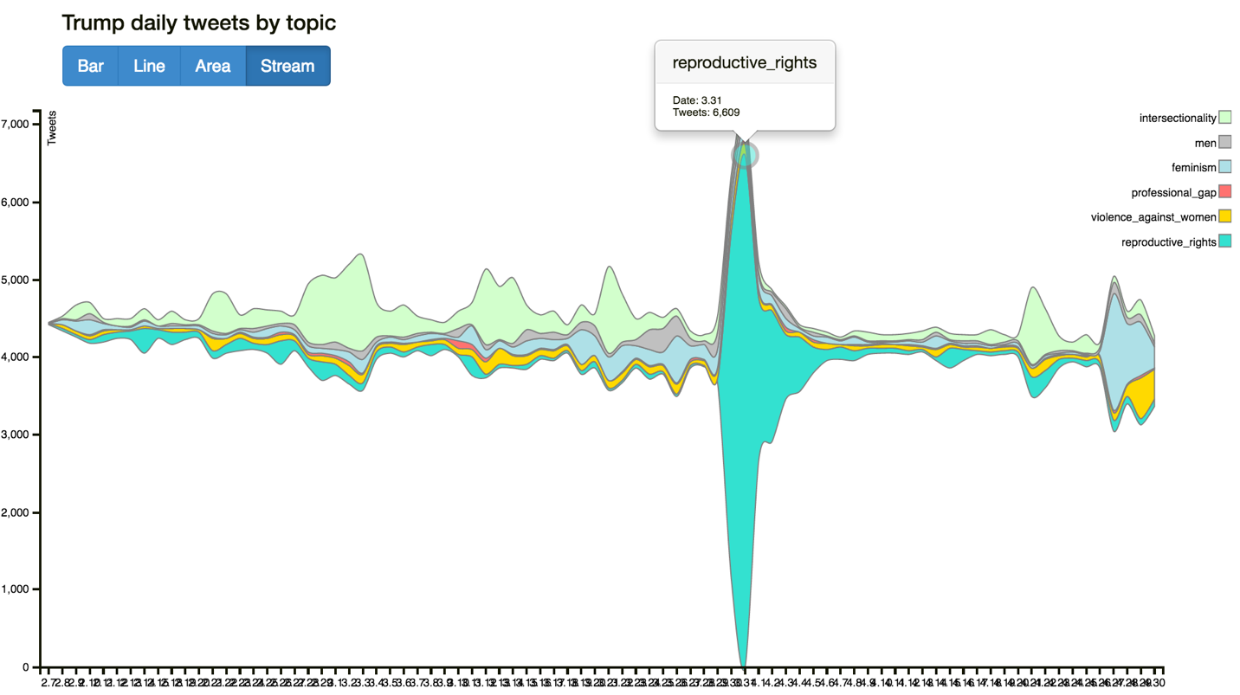

Having looking up on the internet, we found that Trump was pressed by Matthews during a town hall on March 30 about whether he believed a "woman be punished for having an abortion?" Trump responded, arguing that "there has to be some form of punishment" for women who get an abortion.

Here is what we’ve found on The New York Times about this: “Donald J. Trump said on Wednesday (March 30) that women who seek abortions should be subject to “some form of punishment” if the procedure is banned in the United States, further elevating Republican concerns that his explosive remarks about women could doom the party in the fall. The comment, which Mr. Trump later recanted, attracted instant, bipartisan criticism — the latest in a series of high-profile episodes that have shined a light on Mr. Trump’s feeble approval ratings among women nationally.”

There is no doubt that right wing media figures expressed immediate displeasure with Trump's initial remarks calling them "awful," "tone deaf," and "ignorant." And of course, they would mention Trump on their Twitter account, or comment on Trump. Here are some examples:

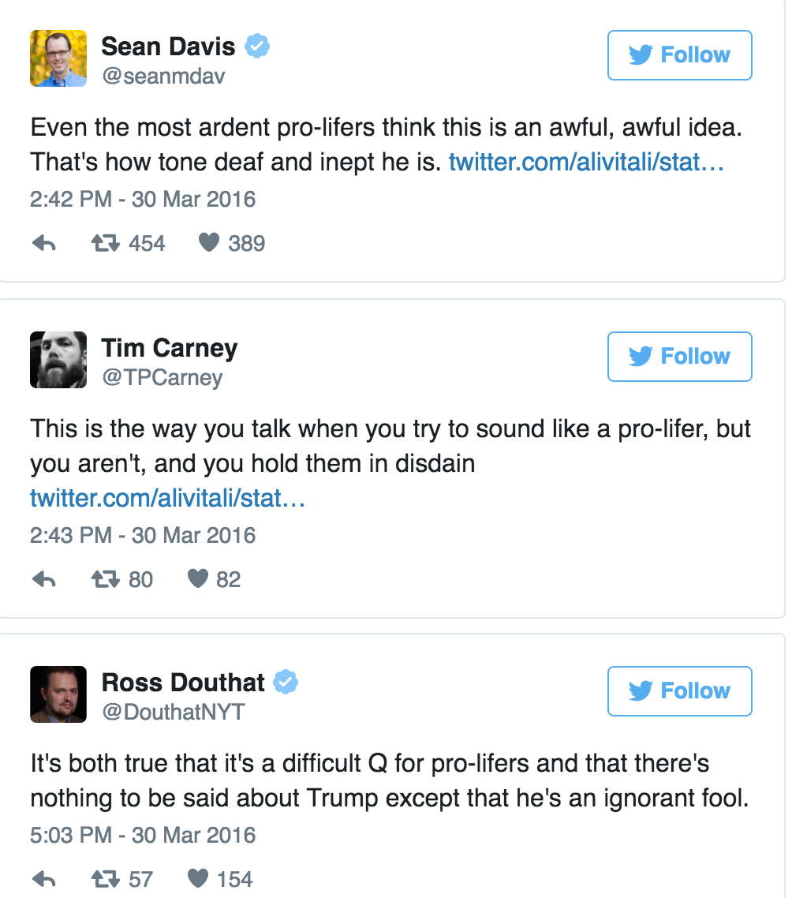

On the same day, Trump attempted to walk back his remarks later, issuing a statement that said the punishment for abortions should be restricted to "the doctor or any other person performing this illegal act ... not the woman", which consequently made more people focus on his remarks on abortion and productive right.

Not surprisingly, other candidates would definitely seize this chance to attack Trump during the campaign as responses, especially the two candidates from Democrats:

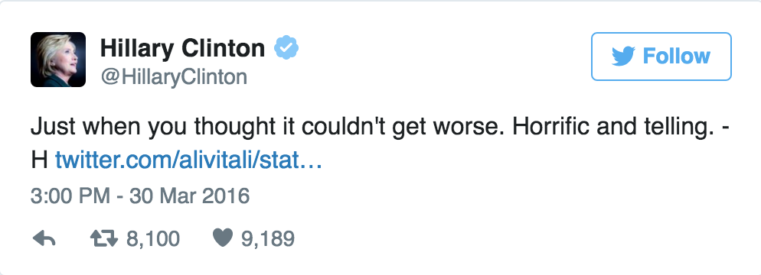

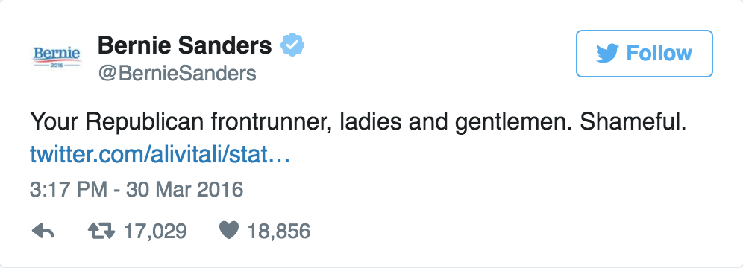

The direct result is that for tweets of Hillary Clinton and Bernie Sanders, the topic on “reproductive right” also increased, although the total number is not as high as Trump’s. This phenomenon is particularly obvious on March 31th, the same day of the Trump’s “tweet peak” happened. The result of this interaction on Twitter is very clear on our d3 dynamic charts for Hillary Clinton and Bernie Sanders:

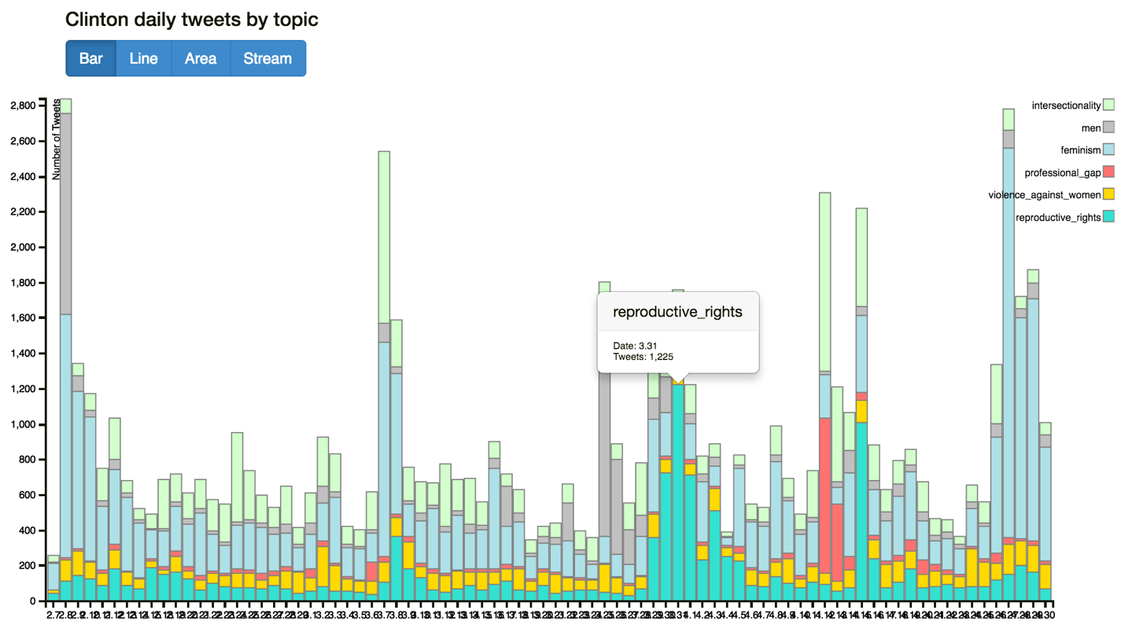

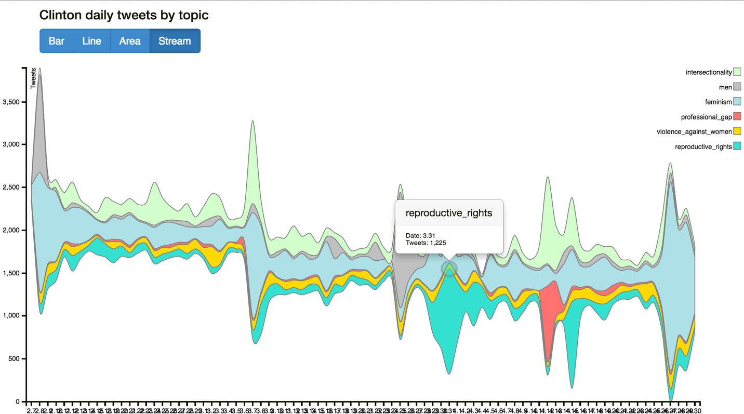

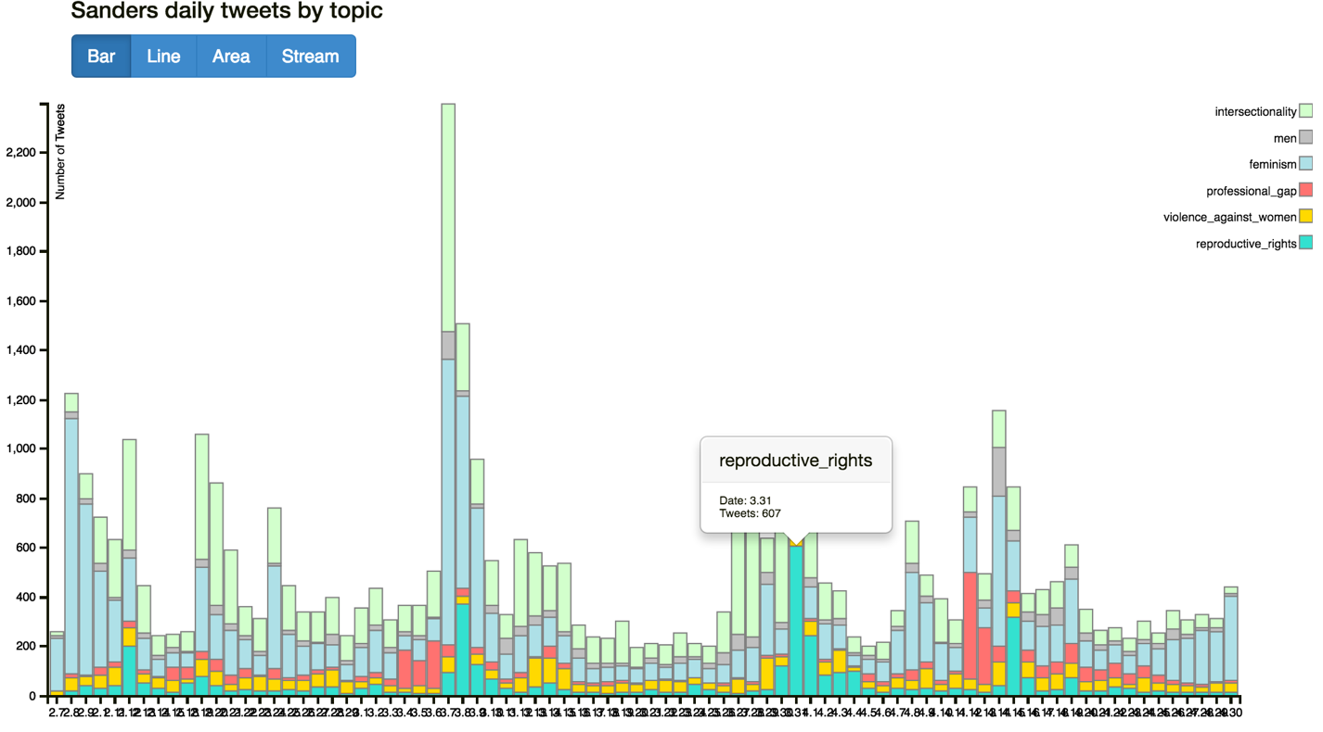

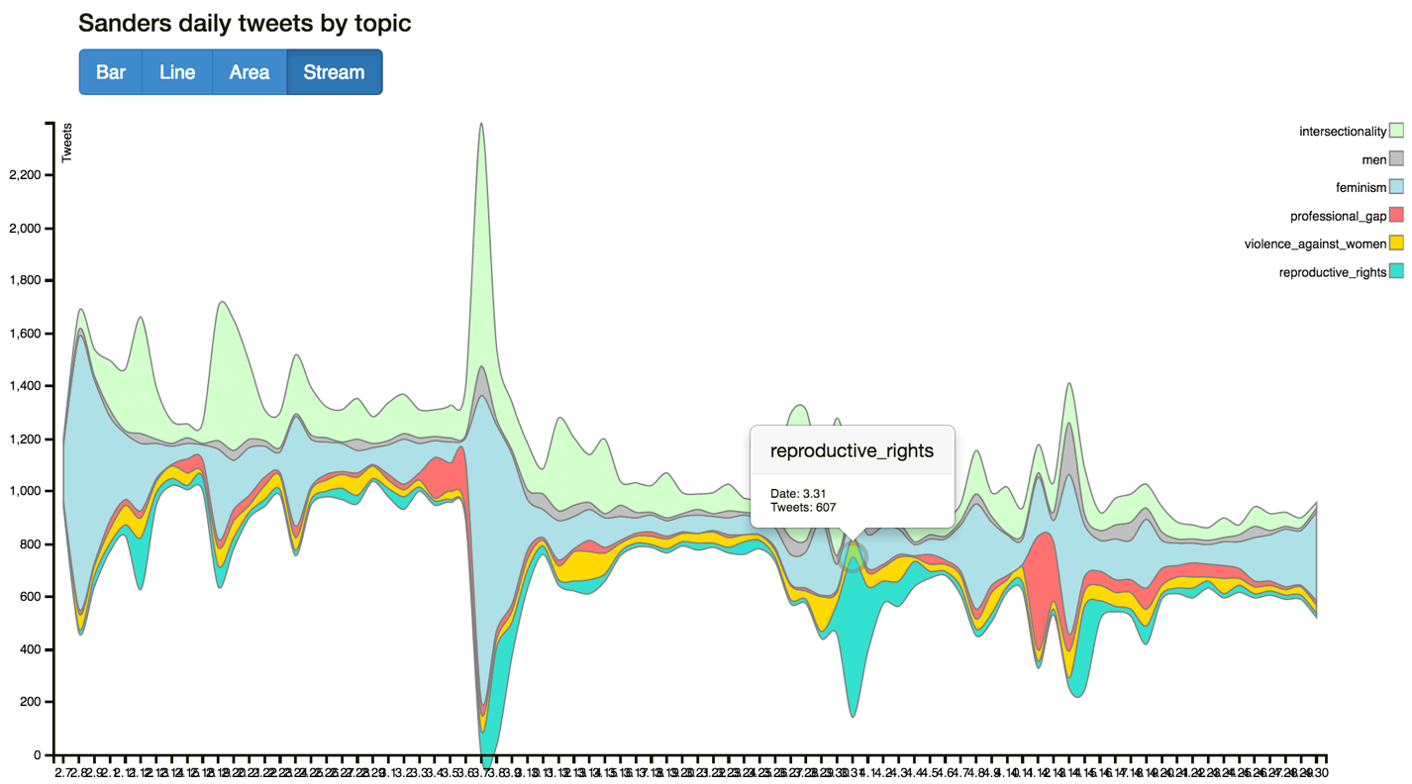

From the plots of Clinton and Sanders, we could easily see that on March 31st, tweets on reproductive also got their peak number on the time range from February 7th to April 31st. Compared to Clinton, we could easily conclude that this sudden increase of Sanders is mainly due to his reaction to Trump’s remark. This is because in general his tweets on this topic is always very small among four candidates – the only plausible reason of this growth is his response to Trump’s speech at that day. Although the absolute number of his tweets is not very high (607) comparing to Trump’s (6609) and Clinton’s (1225); it is impressive enough for Bernie Sanders’ himself.

From these d3 dynamic charts for four candidates, another interesting fact is the huge increase on “professional gap” topic from Hillary Clinton’s tweets. It is very intuitive from our plots:

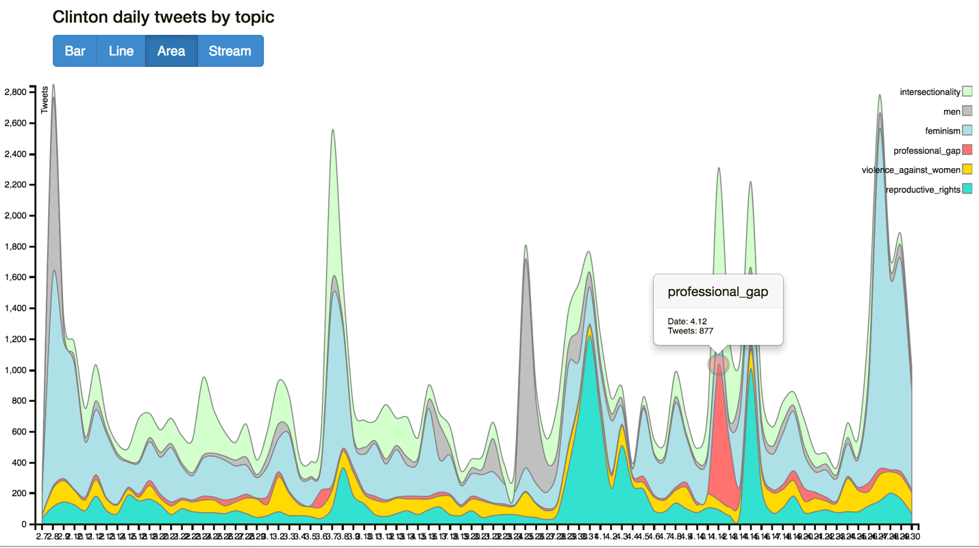

The red area, which stands for the topic of “professional gap”, takes up an incredible large area around April 12th. Since this issue is not a very popular topic in most of the days, there must be some related event or speech delivered by Hillary Clinton, or mentioned her on that day.

After searching “April 12 Hillary Clinton professional gap” online, we found that Hillary Clinton outlined her plan for closing the pay gap between men and women at a roundtable in midtown Manhattan on that day. According to Hoffington Post, Clinton said the followings at the gathering, which was sponsored by the salary site Glassdoor: “Last time I checked, there’s no discount for being a woman. Groceries don’t cost us less, rent doesn’t cost us less, so why should we be paid less?” The pay issue was on the agenda because April 12 is Equal Pay Day — the day U.S. women’s earnings finally catch up with what U.S. men already earned at the end of 2015.

Since we used “equal pay” as one of our keywords for “professional gap”, of course a lots of tweets have been collected and categorized under this topic. Some social media were even saying “Hillary Clinton = A fighter for equal pay”, making Clinton become more connected to this topic. Consequently, as the frontrunner of Democrat Party, there would certainly many public figures and common people on Tweeter respond to this.

Clinton’s rival for the Democratic nomination, Sen. Bernie Sanders, tweeted a call for pay equality at the same day, which could be proved by our chart: 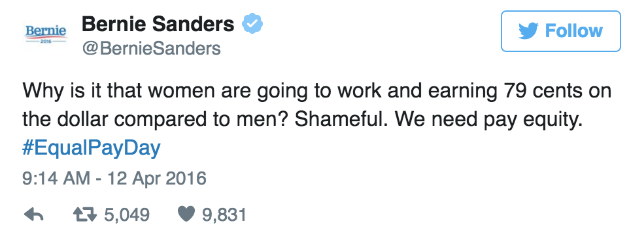

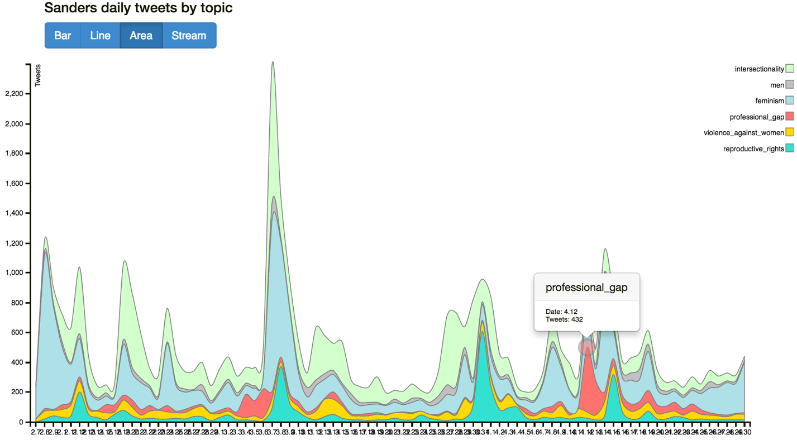

The Republican candidates weren’t talking as much about pay equality, an issue that exposes a pretty stark partisan divide.

Sen. Ted Cruz has voted against the Paycheck Fairness Act, a bill floating around Congress that would bolster legal protections for those seeking fair pay.

GOP front-runner Donald Trump has said women should make the same as men if they do “as good a job.” He’s made statements supporting equal pay, but hasn’t offered much in the way of substantial policy recommendations.

Our charts provide a more intuitive way comparing each candidates on this topic – Cruz has some tweets on this at April 12th (it seems that for Cruz, the most tweets on professional gap happened on that day, too); whereas there was almost no tweet on equal pay or any other related topics:

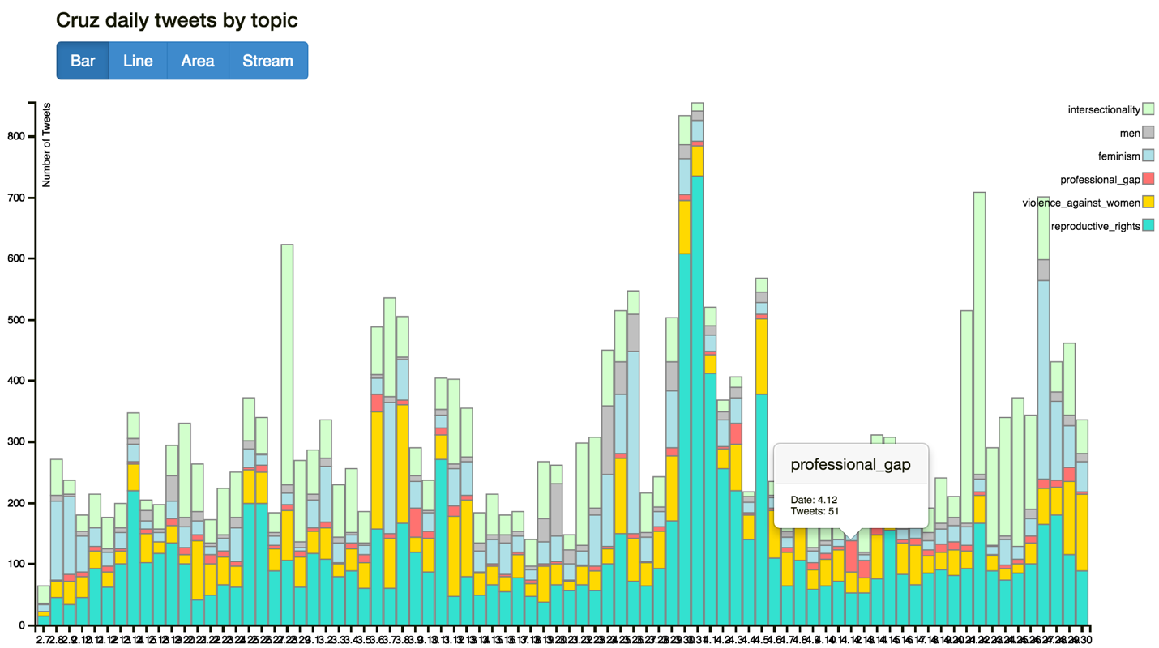

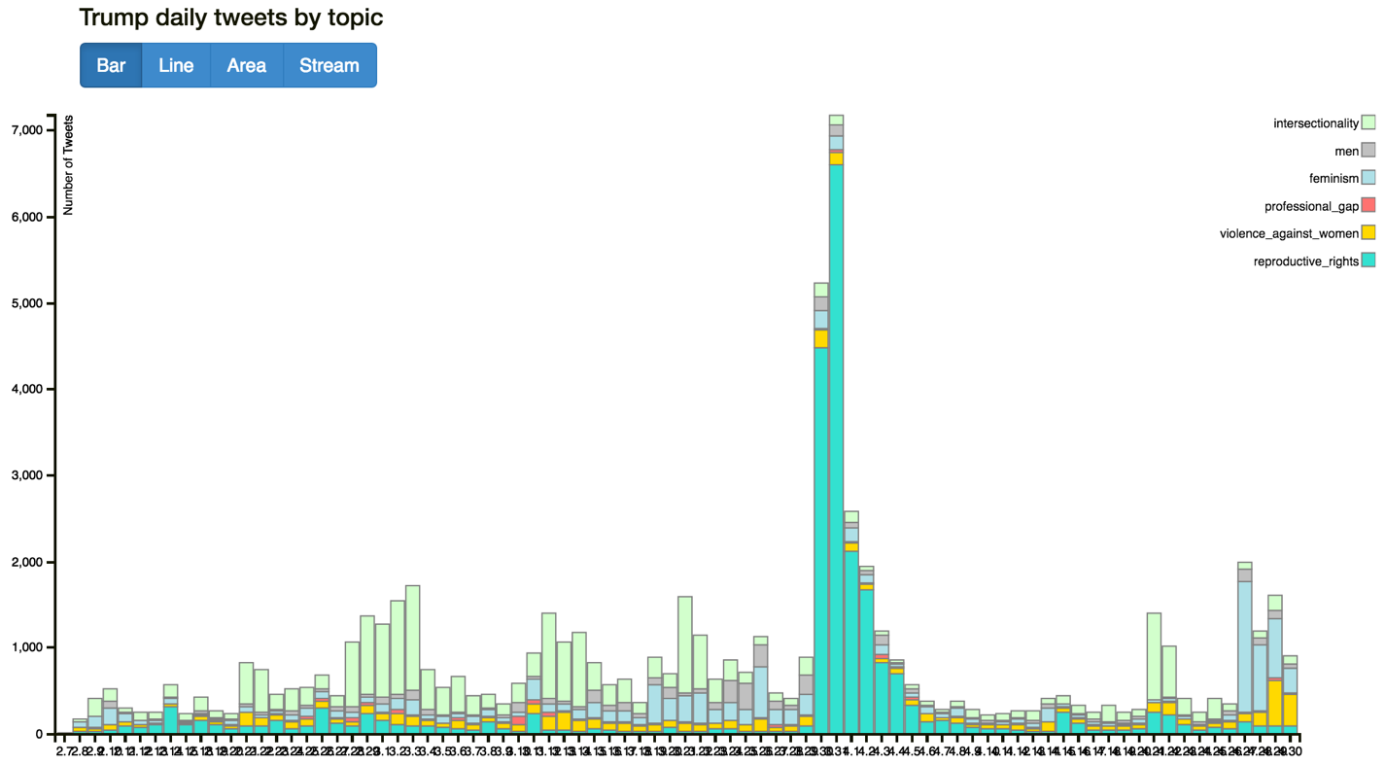

Since The hashtag #womancard caught fire on an array of social media platforms, especially Twitter, and some candidate even used it as their complain strategy, we decided to look into it by our charts. As we all know, since late April, “women card” becomes a major issue on social media and online discussions.

Donald Trump says it's a method used by his rival Hillary Clinton to win votes.That claim has opened up a backlash against the woman card term, but it does not seem to slow down or affect Trump much at all. It may, however, affect his chances to become president.

With at least 58,000 tweets by April 27 evening, #womancard was the highest trending word on Twitter on the day after big primary wins in five states by Trump. In his victory speech, Trump repeated a theme he's begun saying frequently in recent days.“I think the only card she has is the women’s card,” Trump said. “Frankly, if Hillary Clinton were a man, I don’t think she would get five percent of the vote.”

For her part, Clinton won four of the five primaries on that day, and in her victory speech, an electrified former secretary of state had a response for the Republican front runner: “The other day, Mr. Trump accused me, of playing the, quote, ‘woman card,’” Clinton said. “Well, if fighting for women's health care and paid family leave and equal pay is playing the woman card, then deal me in.”

Although in this project we only use the tweets end at April 30, we still want to see the general trend of this – we used two related topics “men” (grey areas on charts) and “feminism” (light blue areas on charts). Here are the screen shots of four stream chart, since we think this is the clearest way to do comparison for a long time range:

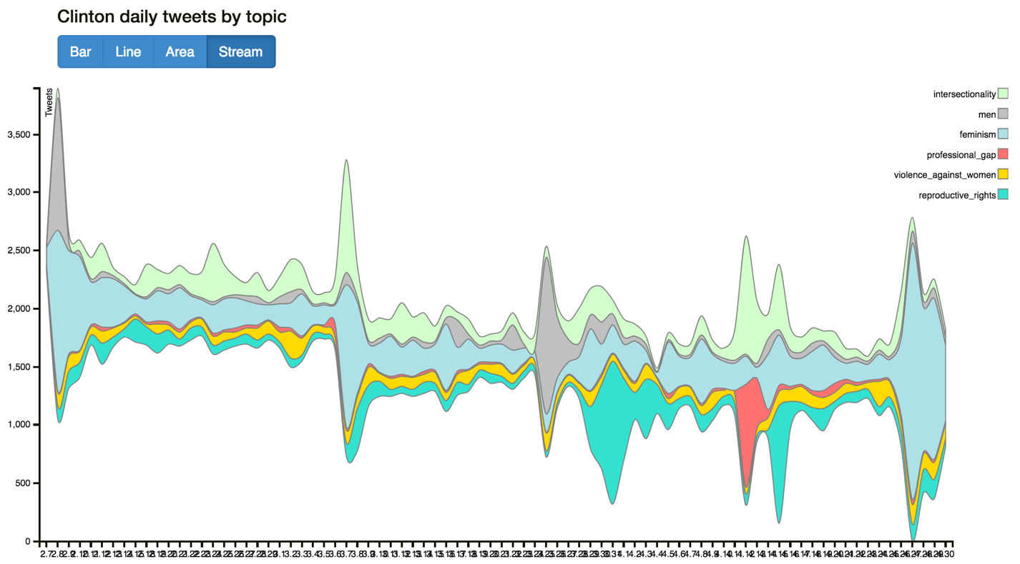

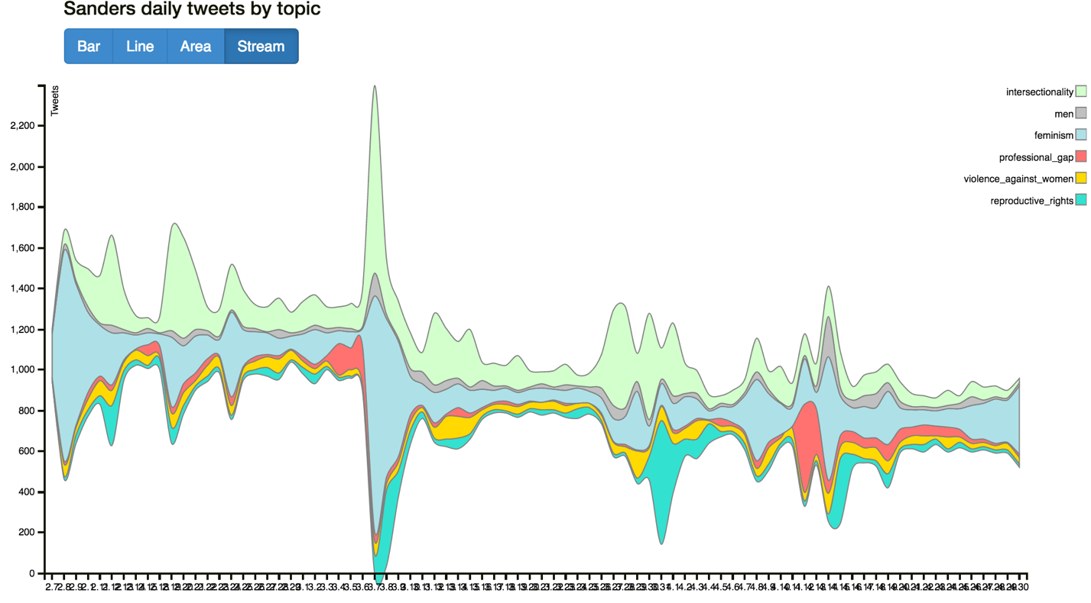

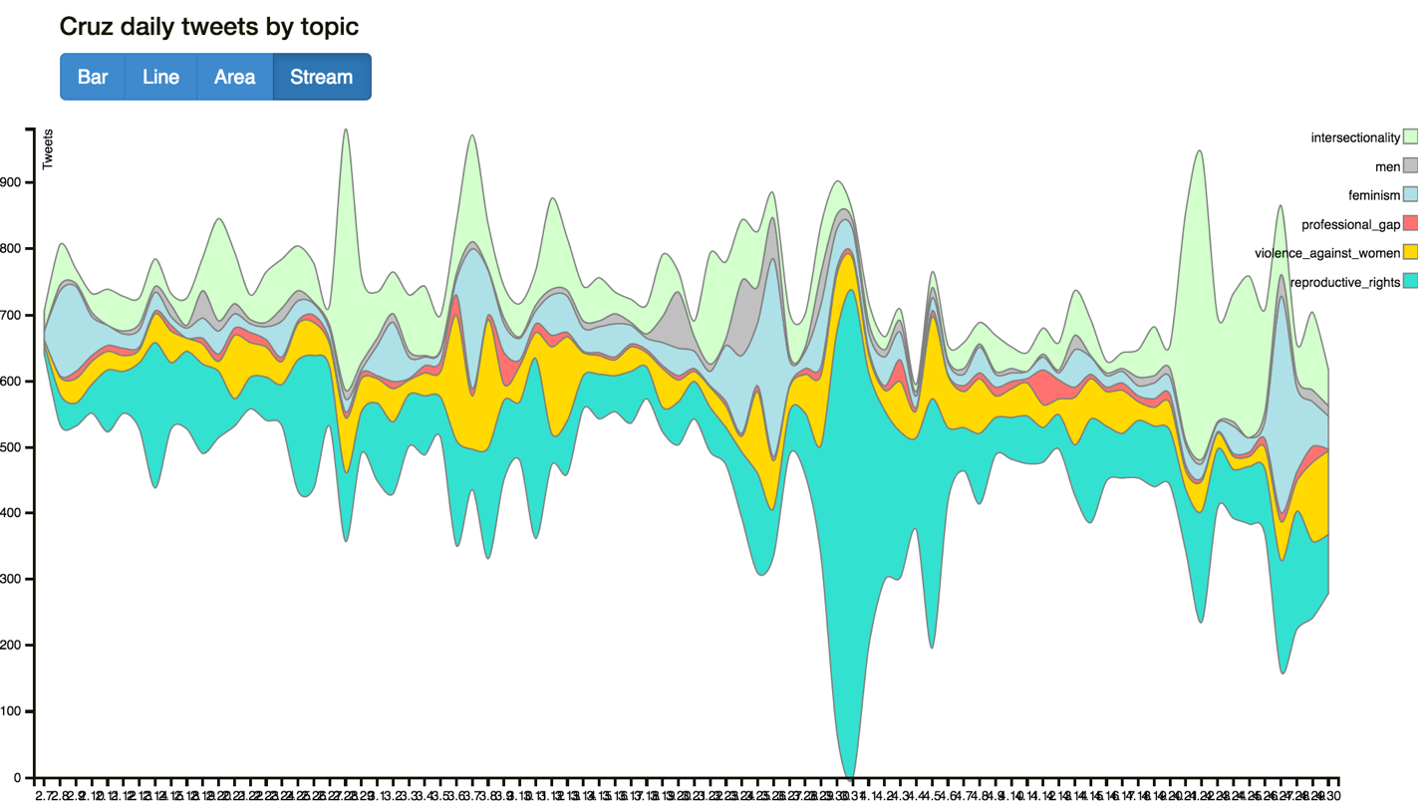

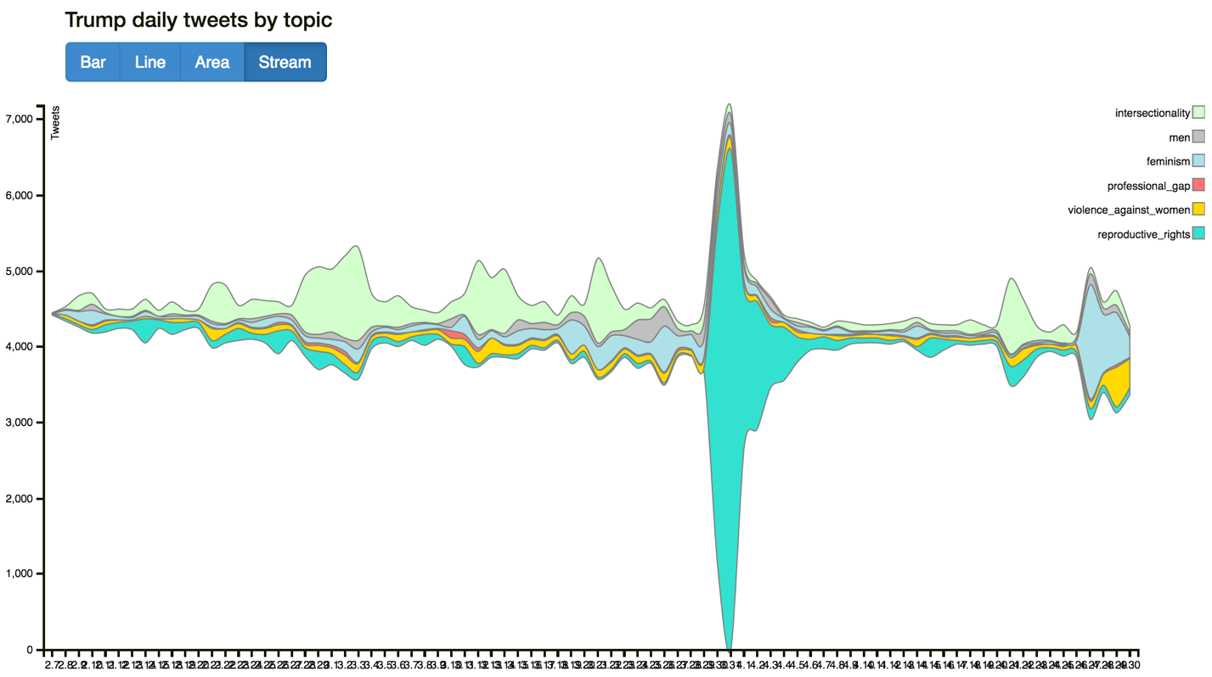

From the above plots, apparently Clinton and Trump have the most tweets on this issue (the areas on Trump’s chart are not very large due to the scale of y-axis is larger than other plots); followed by Sanders; and the last is Cruz. This conclusion goes along with fact of this campaign – Hillary Clinton is the major promoter of women card, and Trump is a super enemy to attack her all the time; as another Democrat candidate, Sanders definitely would make response to Hillary’s action, which leads to his relatively large number of tweets on this issue. As for Cruz, he is not as keen on this women right issue as the other three, consequently the total tweets are the smallest. For the tense relationship between Clinton and Trump on “women card”, this tweet from Clinton shows it clearly:

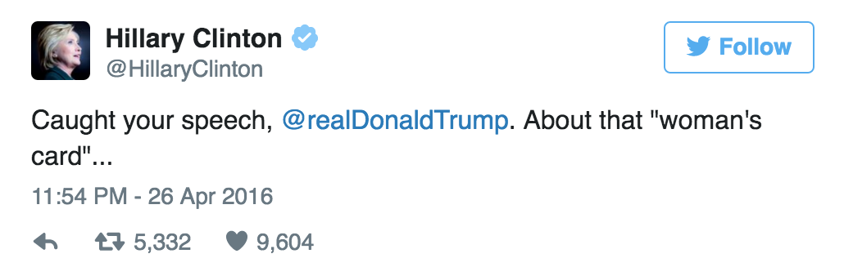

Sentiment Analysis

1) Hillary Clinton

As we’ve discussed above, we calculated the average sensitive score for each candidate by topic, which ranges from 0 to 9, the higher score means more positive. The following plot show how the sensitive score of each topic changed by time (Feb 7 – April 31): for Hillary Clinton, the topic of “professional gap” has the highest average sensitive score (around 6) for most of the time; whereas her policy on “violence against women” and “interesctionality” have the lowest score (between 4 and 5). For other topics are all around score 5, which is the median of the total score range 9.

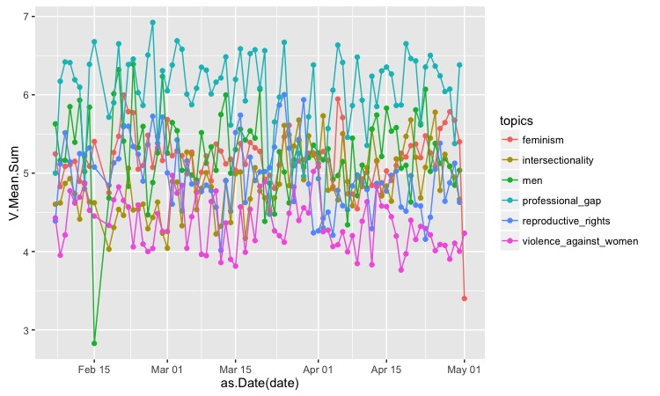

Then we used Google map API to plot the sentiment score on the US map according to the geo location information provided by the original tweets. Since just very small proportion of tweets have their geo information, the following observations and conclusions could not fully present Clinton’s sentiment analysis as a whole.

Based on the distribution of Clinton’s sentiment score, we put the continuous sentiment variables into 6 bins (served as quantile breaks) and marked them with different colors: more black means closer to 0, which means more negative; more red means closer to 6, which means more positive.



These plots go along with the above line plot: topics “violence against women” and “intersectionality” have more black dots; and “professional gap” has mostly all red dot. In addition, generally speaking people from West and East are more likely to tweet their opinions on Clinton; however people living in the North and Midwest tweet less.

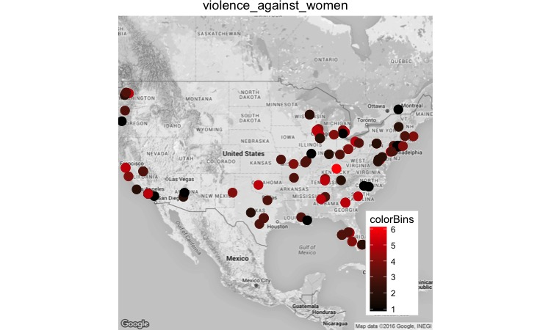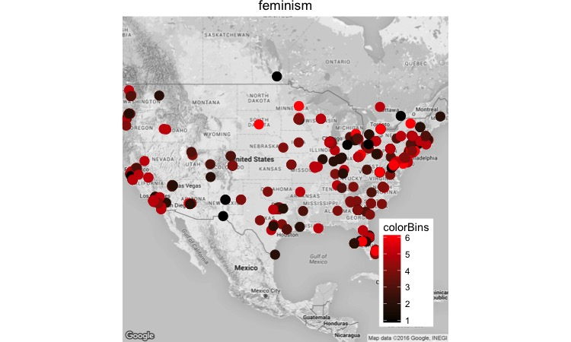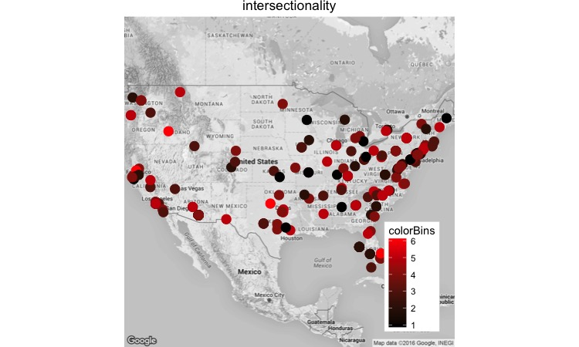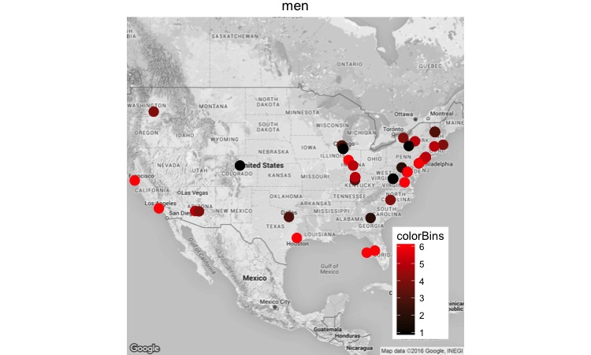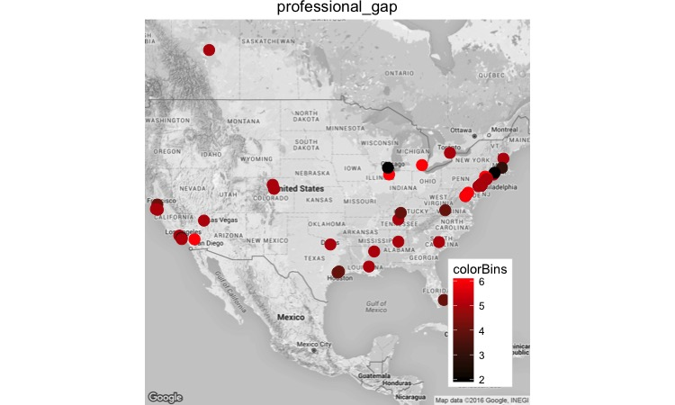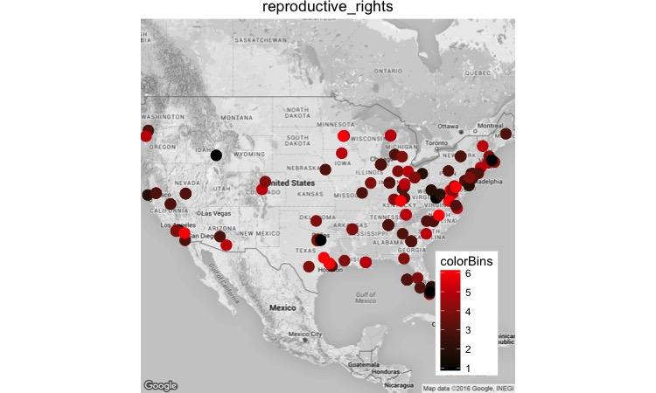

2) Sanders

The whole procedure is same as Clinton’s – from the line plot we could see Sanders gets the highest score on “professional gap”, which is he has been advocating since he became a candidate; then followed by the topic of “men”. For others, his scores are between 4 to 6.

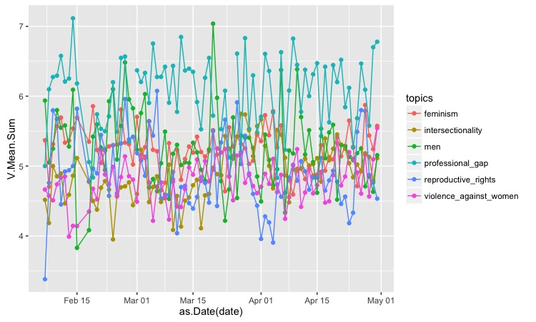

We also used the same mapping procedure to plot the score on US map – although fewer tweets have geo location data, the overall score for each topic is pretty same as what we just concluded. Professional gap has most blue points, which means people have very positive attitude on his policy; but for those more “women right” topics like “feminism” and “reproductive rights”, he is not very popular.

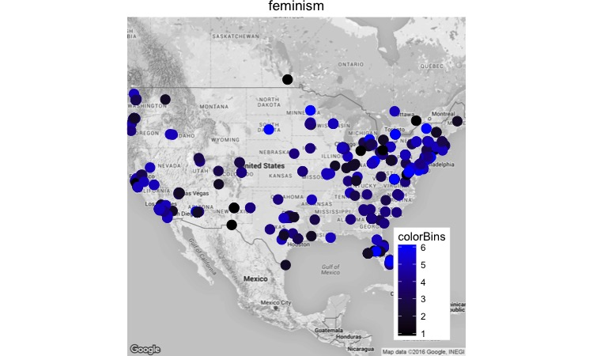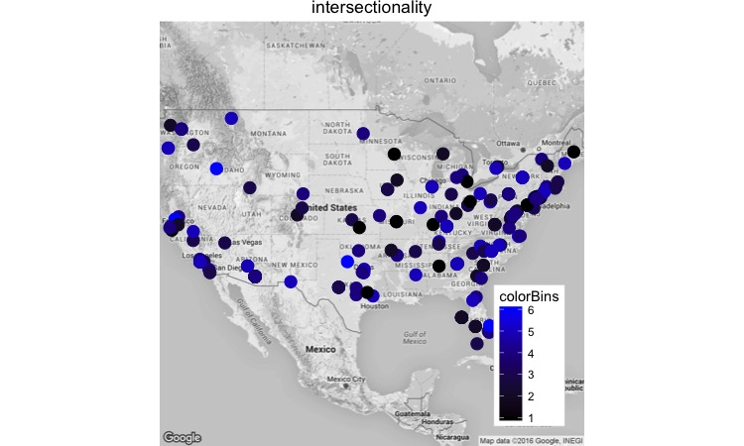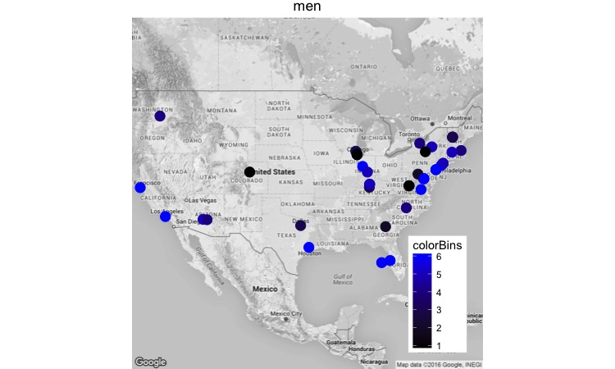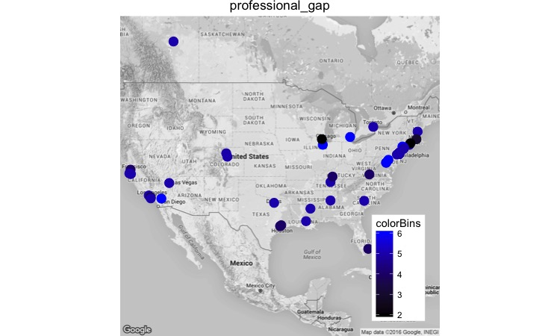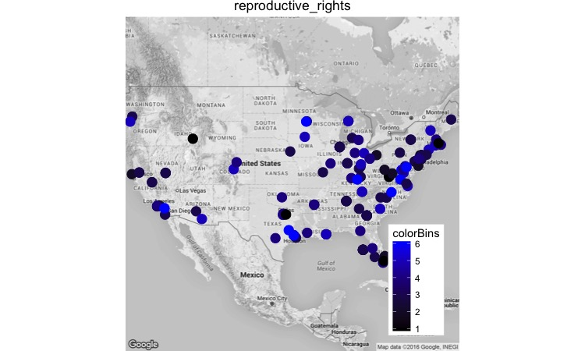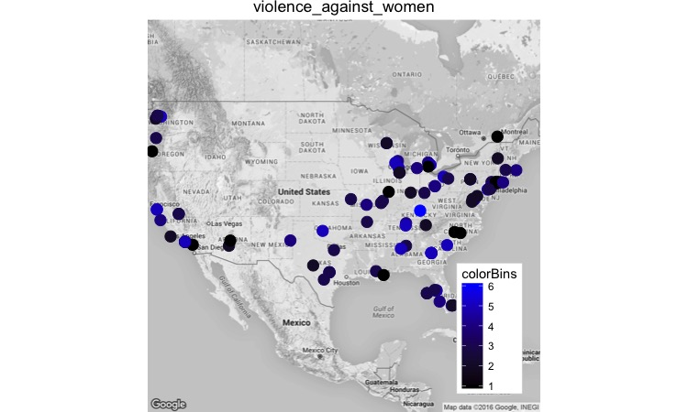

3) Trump

In general Trump’s sentiment score is relatively lower than two Democrats – except for “professional gap”, most of his scores are around 5. The feedback on his “men” issue is particularly low – from mid February to mid March his score is below 4, once even below 3.

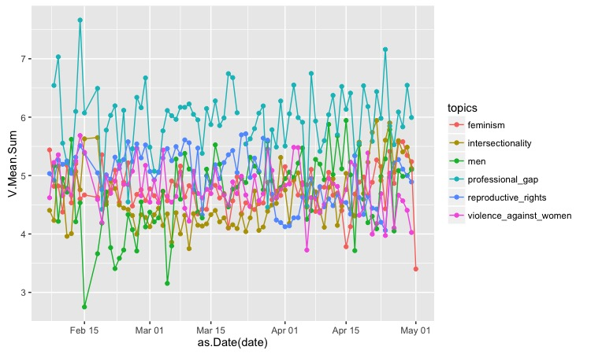

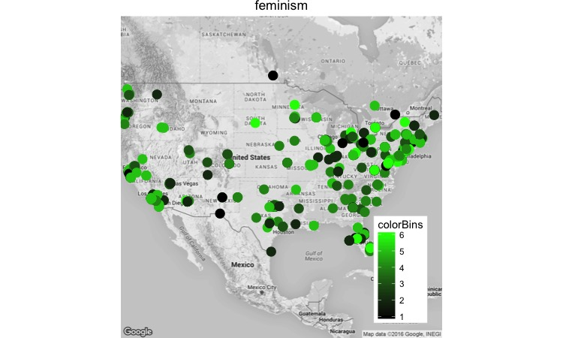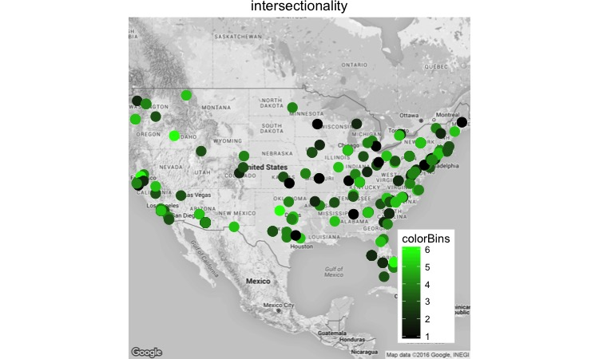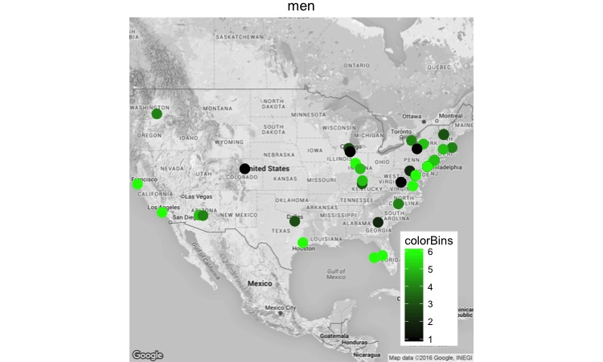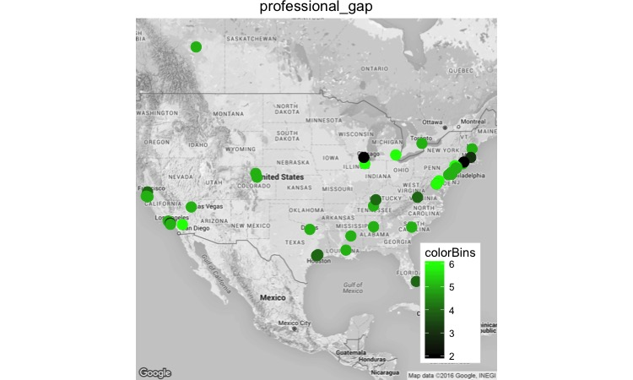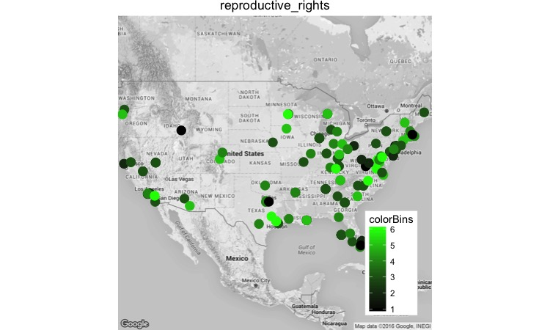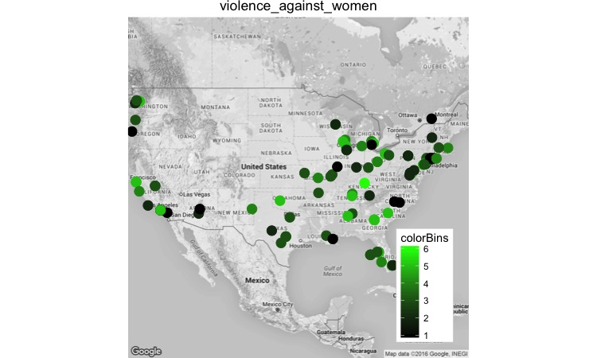

4) Cruz

Like Trump, Cruz also gets the highest score on professional gap, and the lowest score on the issue of “men”. For other topics, his average score is a little bit lower than Trump, mostly scattered between 4 and 5.

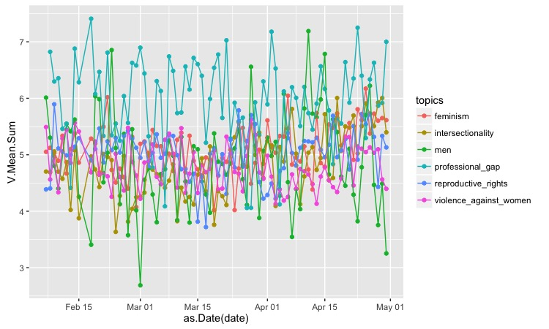

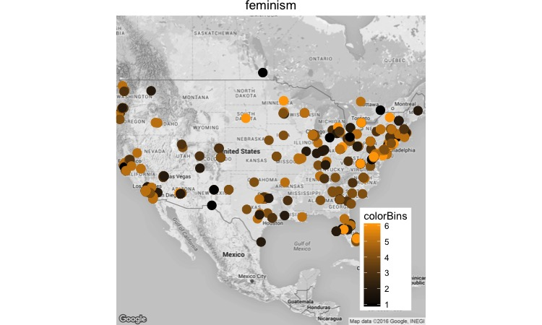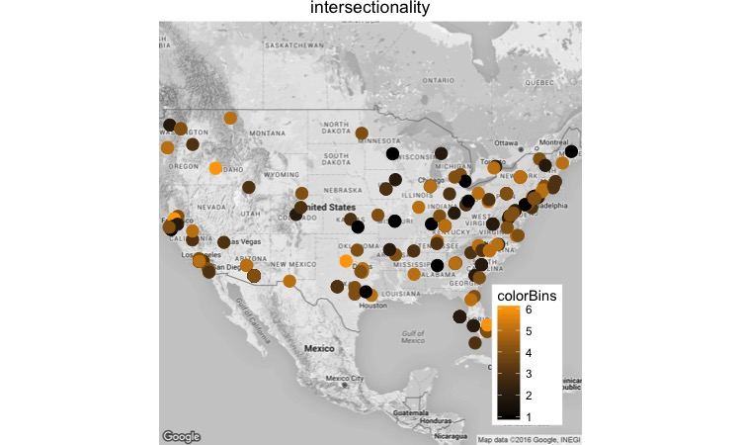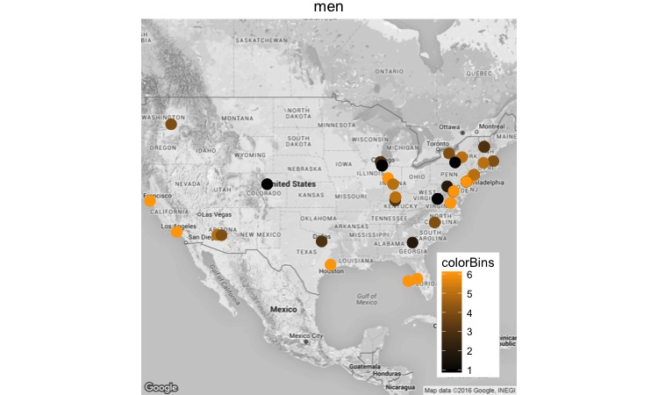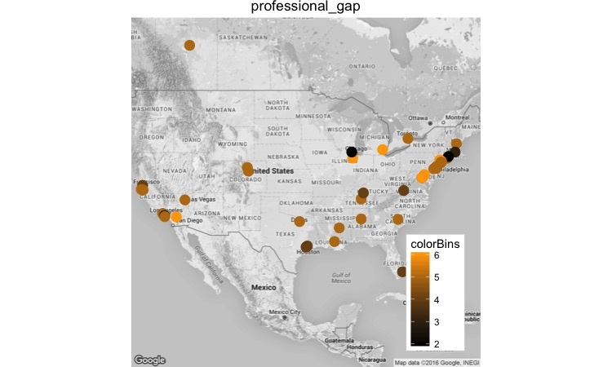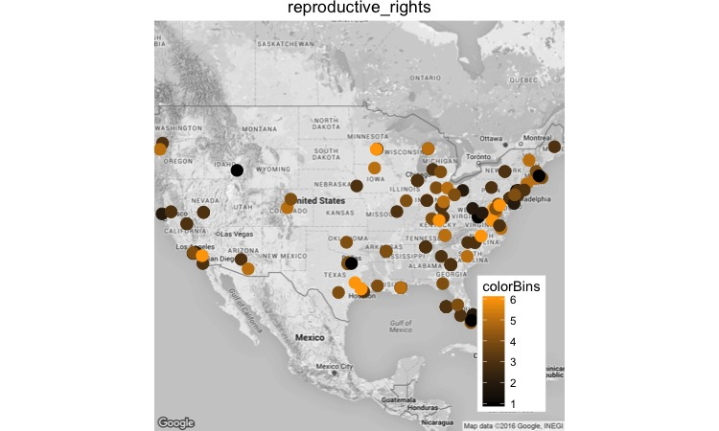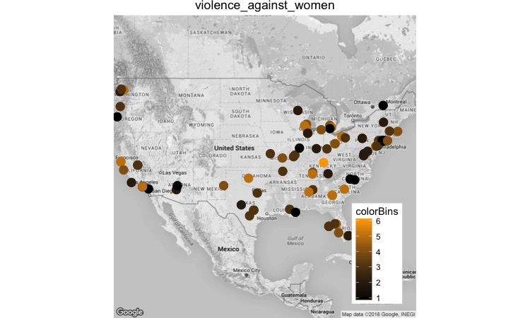

6. DISCUSSIONS AND CONCLUSIONS

7. REFERENCES (could list all the websites we’ve looked up)